Project background: during the laboratory you will get to know the entire pipeline and investigate one of these pipeline elements in-depth. You will get to know and to use various libraries and software tools needed in daily life as biomedical engineer or researcher in the medical image analysis domain.

Project aim:

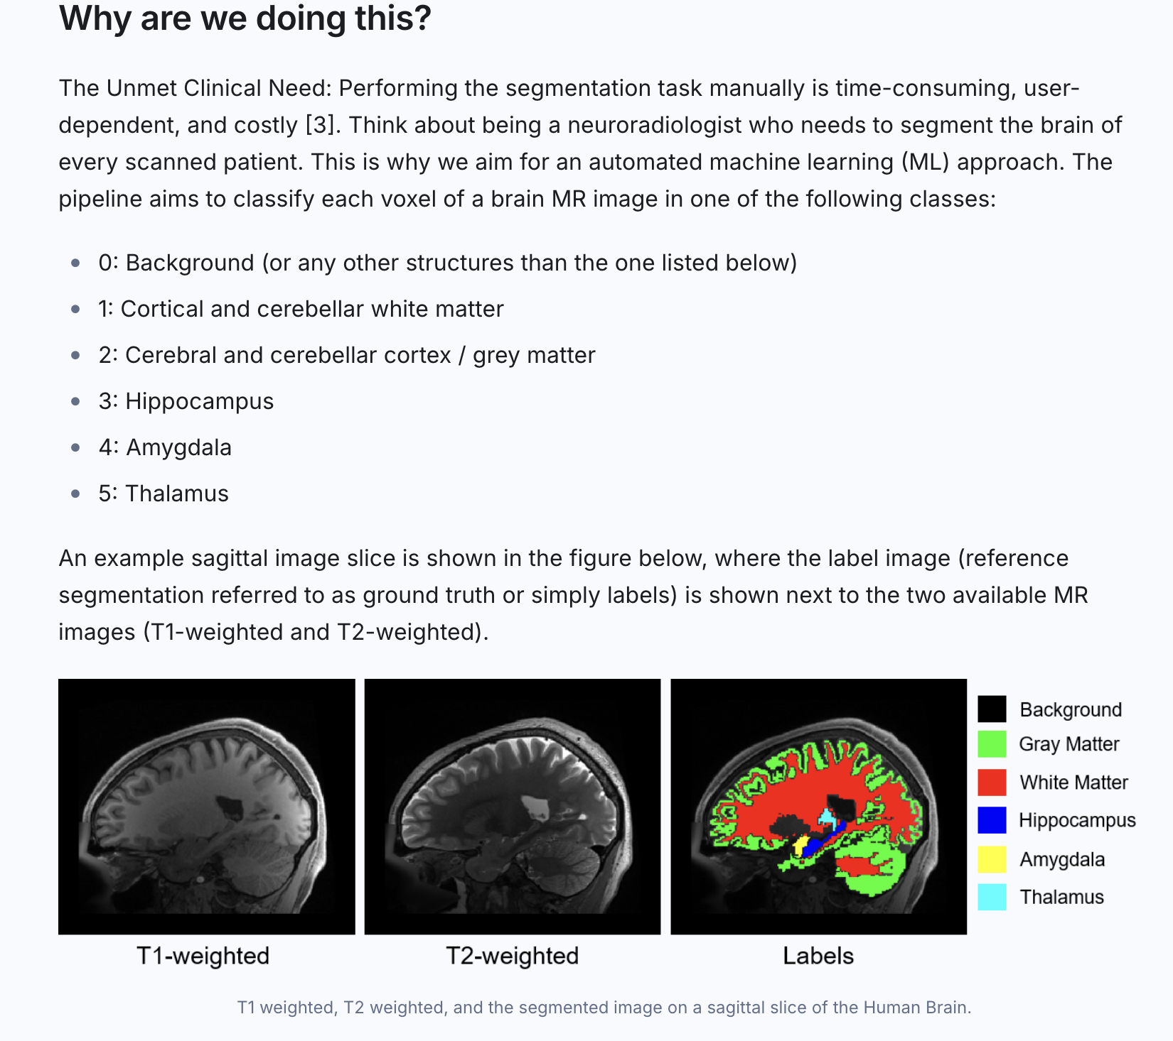
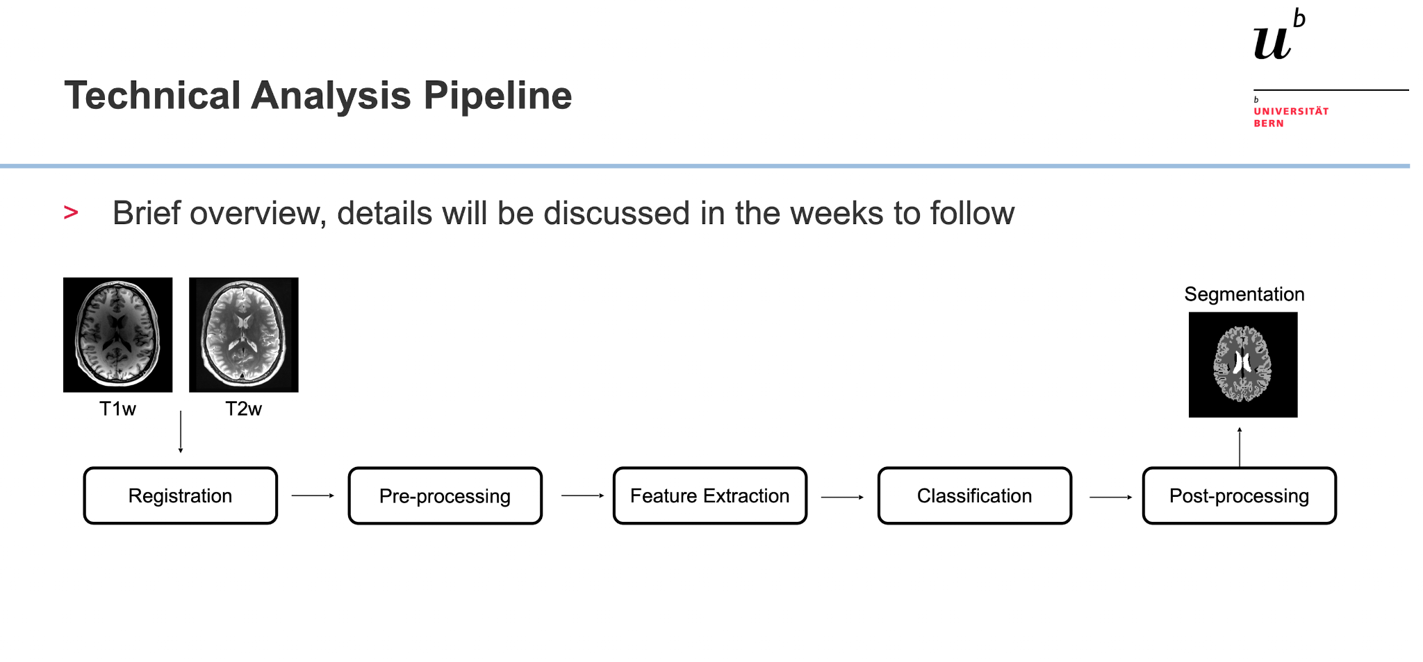

Our project aim:

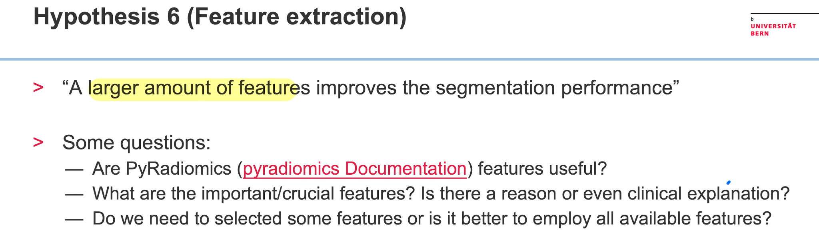
Background knowledge

Feature Extraction

Why is this done?

Feature extraction in medical image analysis is crucial for transforming raw image data into meaningful information that can be used for diagnosis, classification, and prediction. By identifying and isolating relevant features, enhancing the accuracy and efficiency of subsequent tasks. These features can be:

- Shape Features: describing the geometry of structures (e.g., area, perimeter, compactness).
- Texture Features: analyzing the texture patterns within the image (e.g., contrast, entropy).
- Intensity Features: measuring the intensity values within regions of interest.

How is it done?

Feature extraction in medical image analysis involves several key steps and techniques. Here are some well researched methods:

- Local Binary Patterns (LBP): captures texture features by comparing pixel intensities.

- Gray-Level Co-occurrence Matrix (GLCM): analyzes spatial relationships between pixels to extract texture features.

- GLSZM: measures how many connected zones (clusters of voxels) exist for each gray level intensity and zone size within a region of interest (ROI). A zone = a group of connected voxels that all share the same gray level intensity.

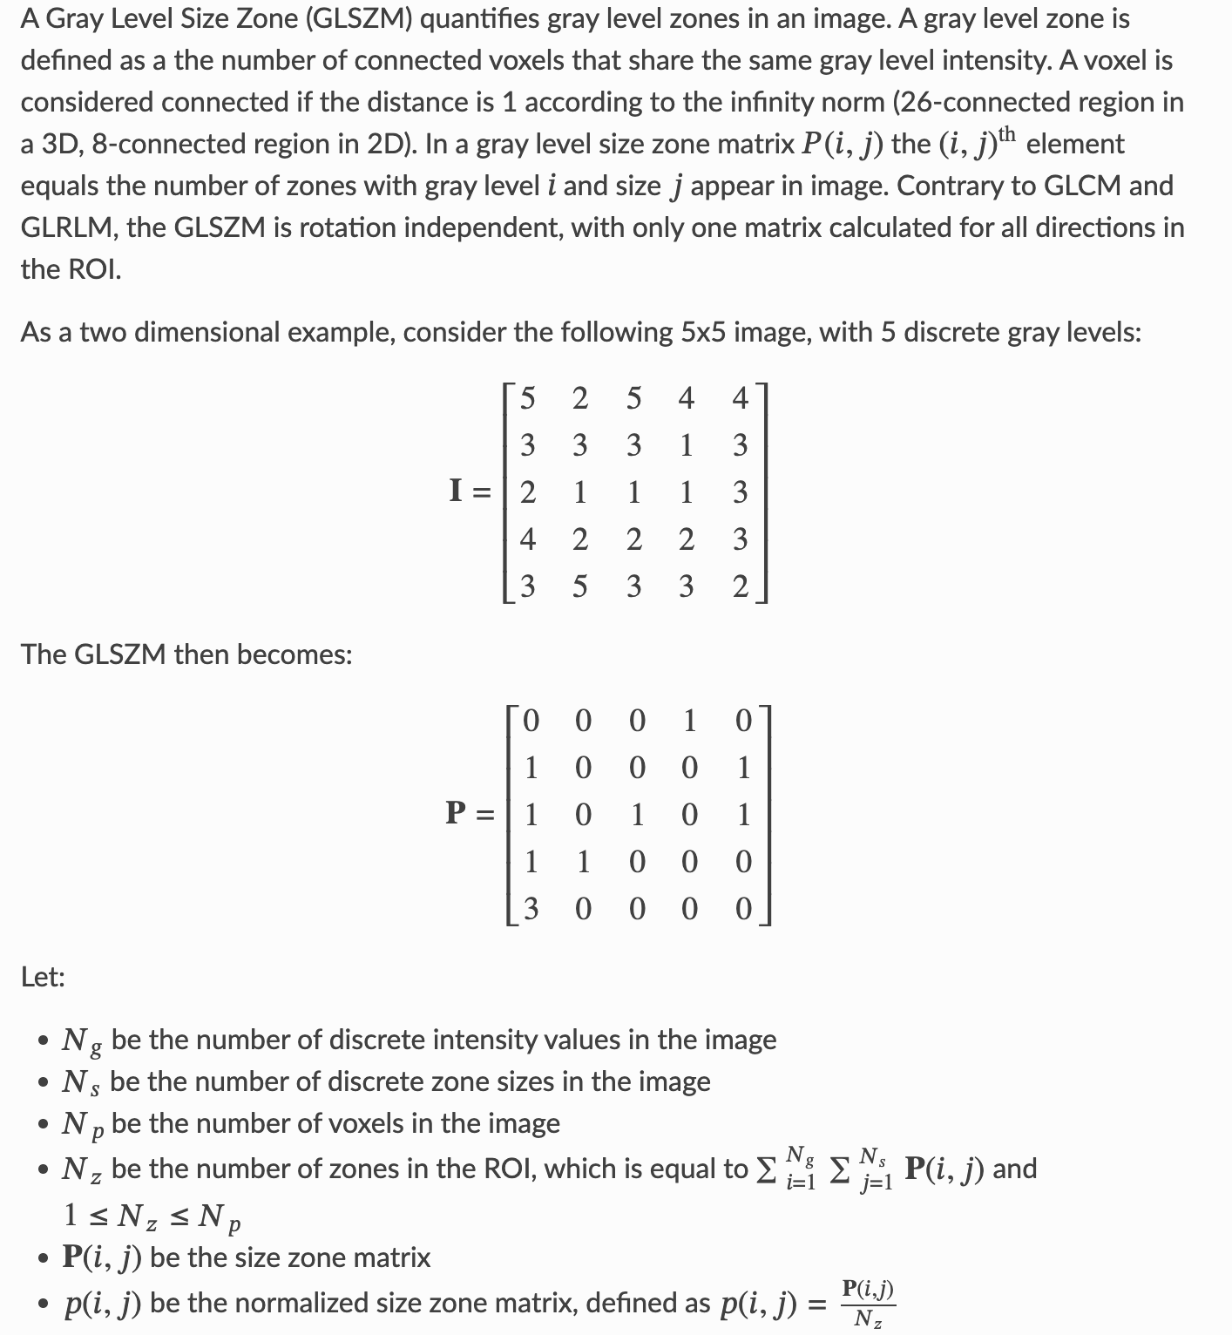

- Gray-Level Run-Length Matrix (GLRM): measures the length of consecutive pixels with the same intensity.
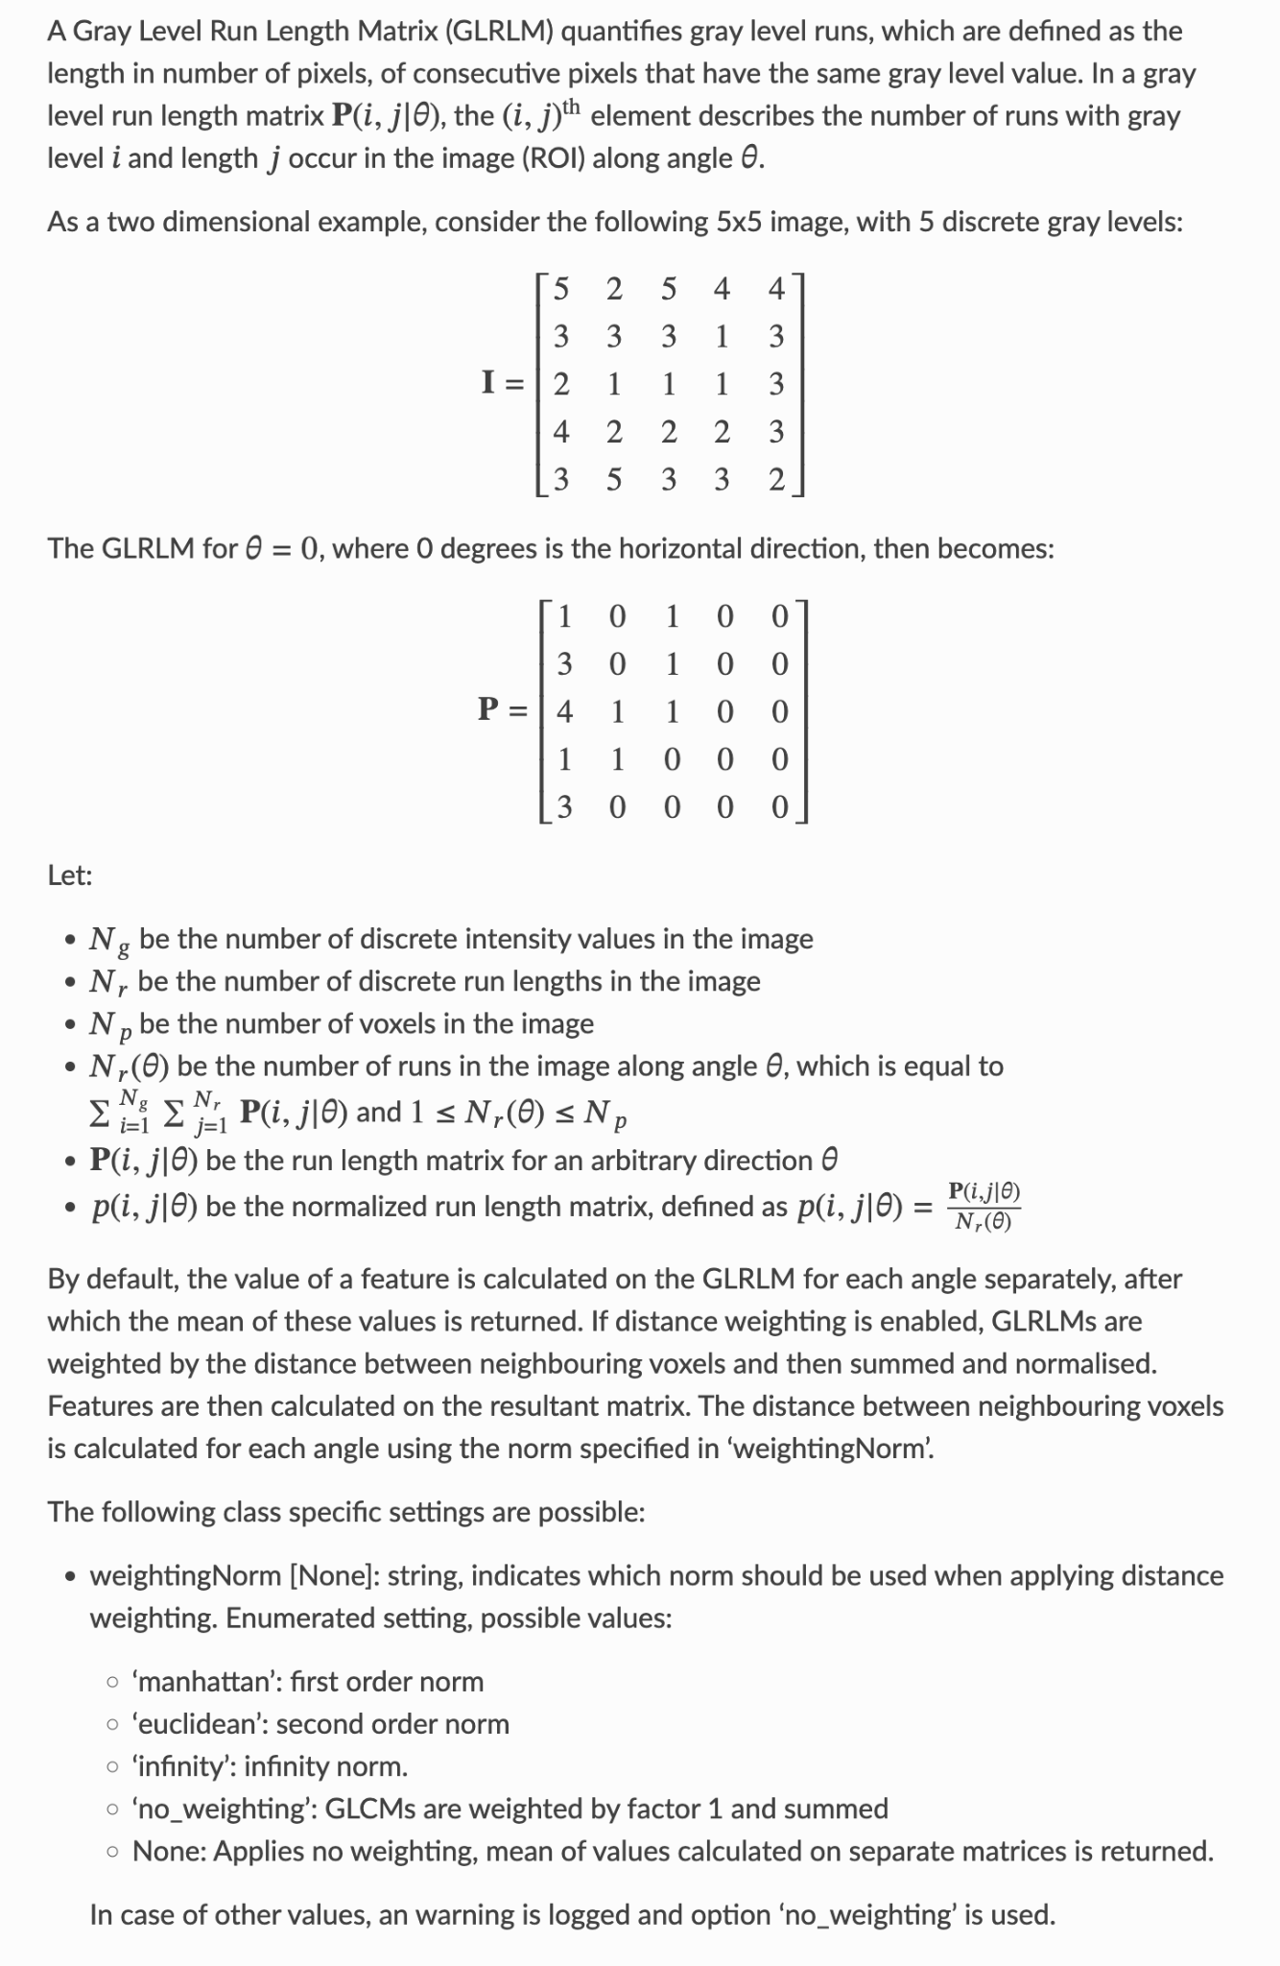
- Completed Local Binary Patterns (CLBP): an extension of LBP that includes additional information about pixel intensity variations.

- Feature Fusion: combining multiple features to improve the accuracy and robustness of the analysis.

- Deep Learning Approaches: utilizes neural networks to automatically learn and extract features from images.

Furthermore, what other features could be used to improve our model?

- Investigate other features

  - Hemisphere feature: The “hemisphere feature” often refers to features extracted separately from the left and right hemispheres of a symmetric structure (e.g., the human brain). In brain imaging, this allows you to compare asymmetries — which can be important biomarkers for neurological conditions (like stroke, tumor, or neurodevelopmental disorders).

  - Filter banks: a collection of filters applied to an image to extract features like edges, textures, or frequency components at different scales and orientations. Typical filters in a bank:
    - Gabor filters: Capture frequency and orientation information (useful for texture).
    - Laplacian of Gaussian (LoG): Captures blob-like structures.
    - Sobel / Scharr filters: Detect edges.
    - Wavelets: Capture multi-scale spatial–frequency information.

  - Histogram of oriented gradients (HOGs): HOG describes the distribution of gradient directions (edge orientations) in localized regions of an image. It’s a powerful shape and appearance descriptor, insensitive to small geometric and illumination changes.

- 2-D / 3-D differences

- 2-D features capture local patterns within a slice, but lose continuity information across adjacent slices. Example: a tumor may appear round in one slice, but its true shape (irregular mass) only becomes clear in 3-D.
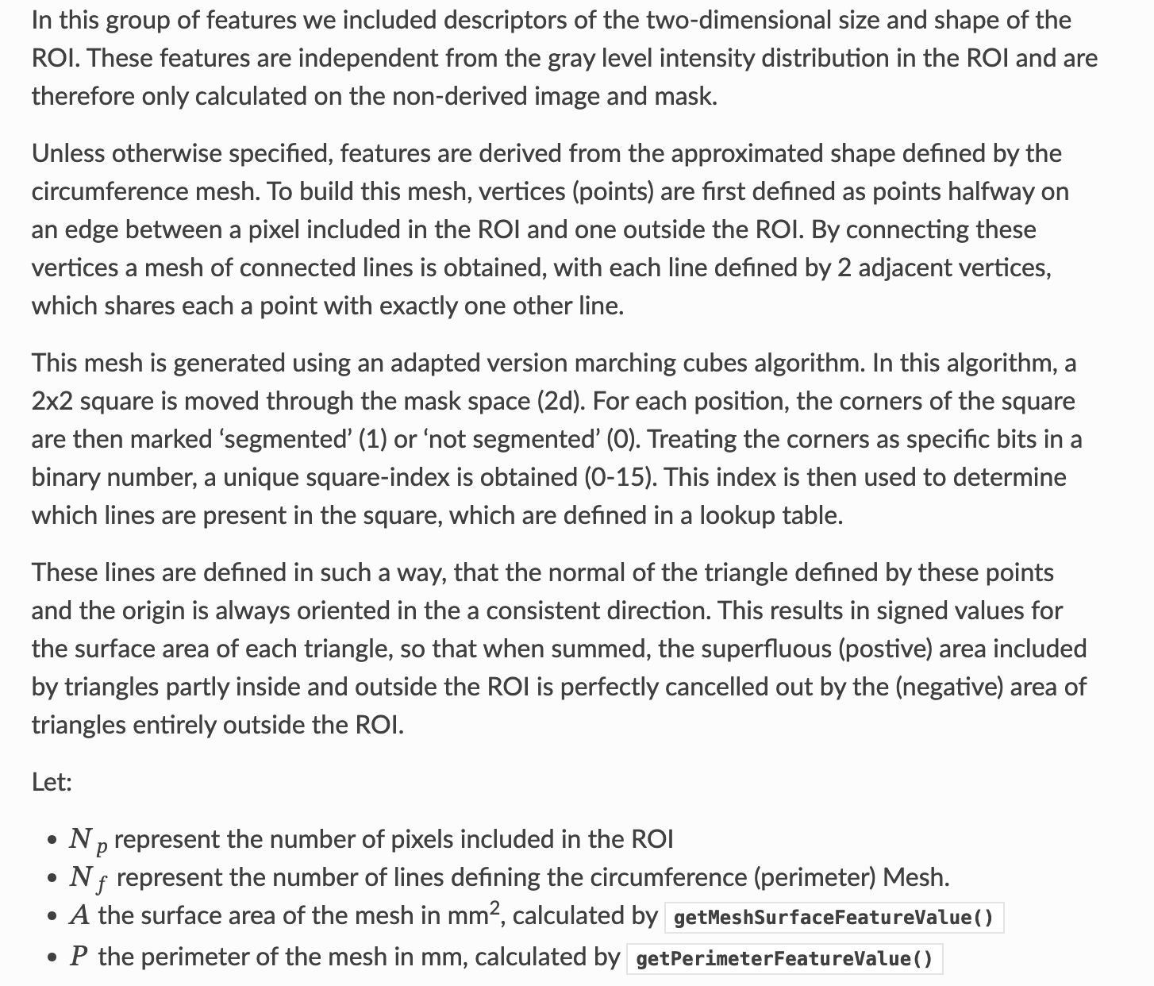

- 3-D features preserve spatial context across depth, leading to more accurate representation of structure, shape, and texture.
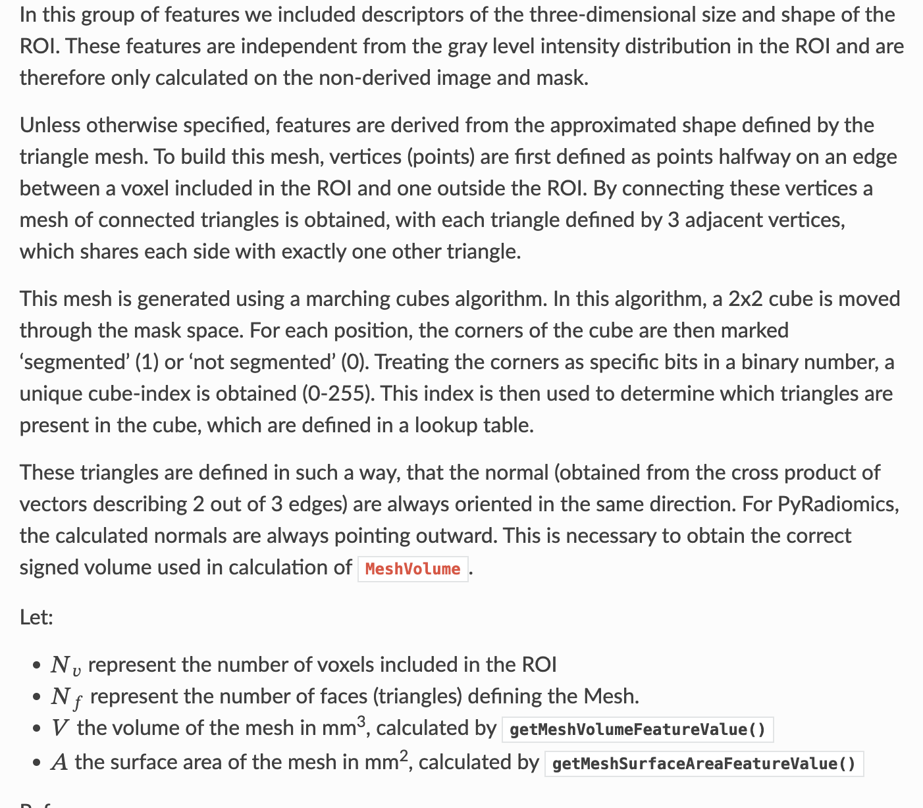

Project ideas after feature extraction

A typical optimization for faster processing is to check if we can reduce the number of features to decrease the model complexity and the computational burden. Some steps in this direction could include:

- Decision forest feature importance
- Principal component analysis (PCA)
- Mutual information based feature selection

Coding Resources

[scikit-image](https://scikit-image.org/docs/dev/api/skimage.feature.html): feature module

[scikit-learn](http://scikit-learn.org/stable/modules/decomposition.html#decompositions): Dimensionality reduction

[Parallelized Mutual Information](https://github.com/danielhomola/mifs) based Feature Selection

References

H. Peng, F. Long, and C. Ding, Feature selection based on mutual information criteria of max-dependency, max-relevance, and min-redundancy, IEEE Transactions on Pattern Analysis and Machine Intelligence, vol. 27, no. 8, pp. 1226-38, 2005.

My Learning:

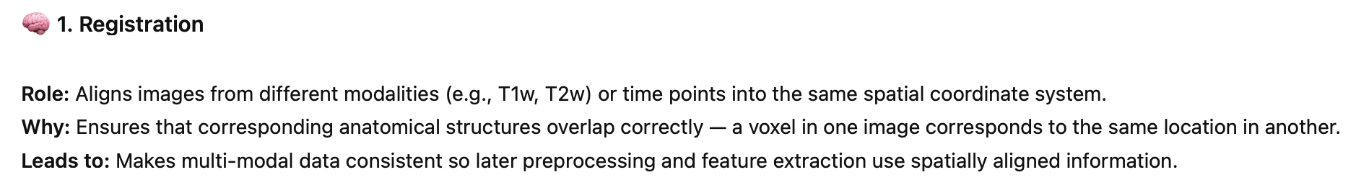

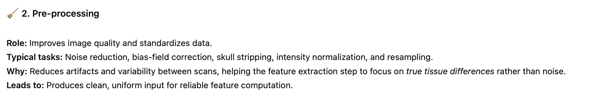

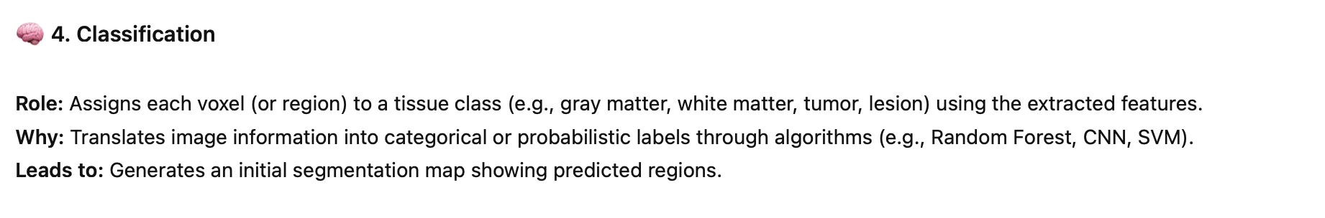
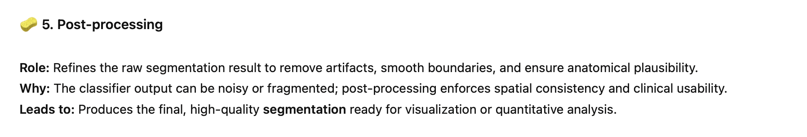

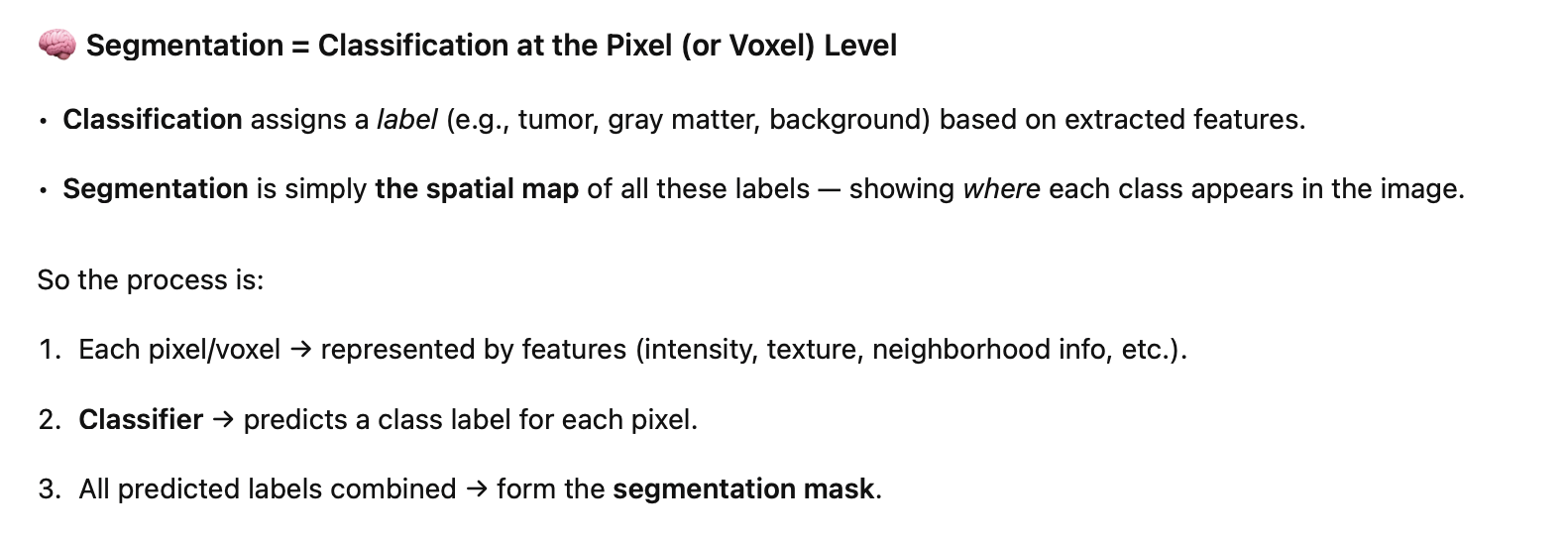

Radiomics features
Radiomics is the process of extracting large numbers of quantitative features from medical images (CT, MRI, PET, etc.) that describe the shape, texture, and intensity patterns of tissues and lesions — turning images into measurable data. These features capture underlying tissue heterogeneity, which often correlates with biological characteristics such as tumor aggressiveness, hypoxia, necrosis, or treatment response.

Four main groups:

First-Order Statistics (Intensity-Based Features): quantify the distribution of voxel intensities within the Region of Interest (ROI), without considering spatial relationships. (Distinguish between solid vs. necrotic tumor regions, or hyper- vs. hypometabolic areas in PET scans)

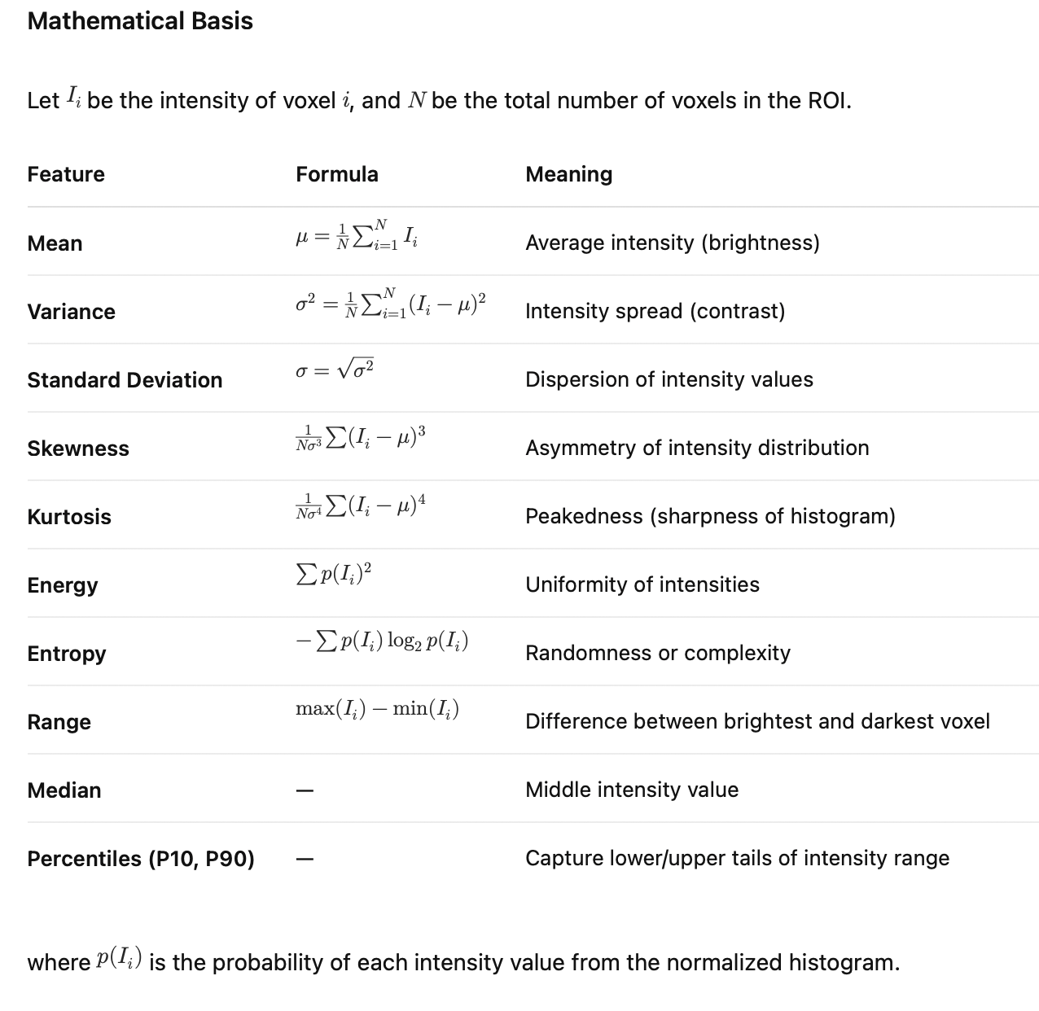

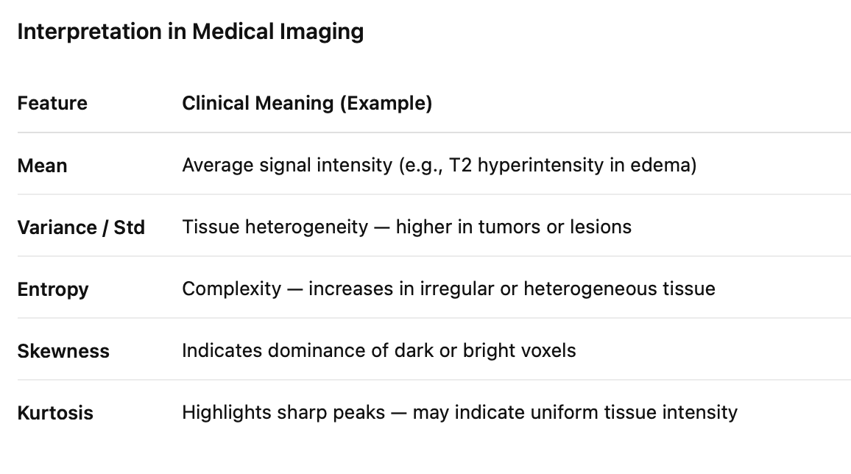

Shape-Based Features (Morphological Features): capture the geometric and spatial properties of the segmented ROI — useful for analyzing tumor size, compactness, and irregularity (Helps assess tumor invasiveness, irregular borders, or mass effect in MRI/CT)

Texture Features (Second-Order Statistics): Texture features quantify spatial relationships between intensities, i.e., how voxel intensities vary locally and globally. They reveal heterogeneity, which can indicate necrosis, fibrosis, or non-uniform cell density.

Higher-Order Filtered Features: Enhances detection of subtle patterns not visible in raw intensity data.

Deep Learning–Derived Radiomic Features (Deep Radiomics): Automatically learned high-dimensional image representations extracted from CNNs (often pretrained networks like ResNet or VGG).

Project overview

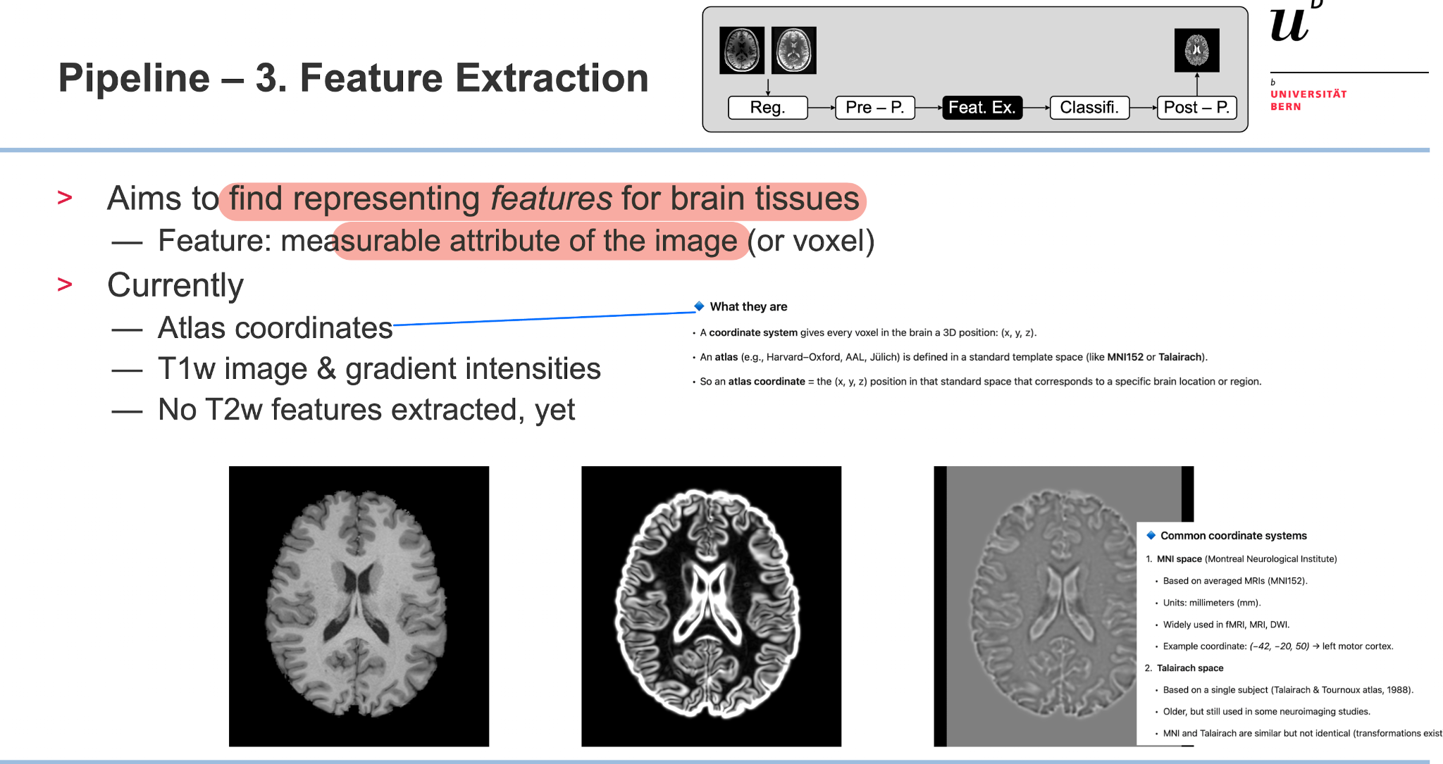

- Data

3 Tesla head MR images of 30 unrelated healthy subjects from the Human Connectome Project (HCP) dataset of healthy volunteers.

- Build MIA pipeline

Our focus:

- Methodology (Focus on feature extraction) based on hypothesis 6:

  - Extract difference features (Radiomics) using PyRadiomics and deep learning-derived radiomic features

  - Answer the following questions by evaluating outcome of MIA pipeline:
    - Usefulness of PyRadiomics- and DL-derived features
    - Feature importance with explanation (clinical)
    - Feature selection based on quality of segmentation

